# Digital image basics

Images are objects that communicate meaning or information. If an image is to be used on a computer, it must be in a digital form.

Images used on computers can be classed as either natural or artificial. A photograph is an example of a natural image. Once the photograph has been digitized (converted into numbers) a computer can store, process and manipulate the image.

Artificial images are those that have been created entirely on a computer using computer processes. There are many programs available for creating artificial digital images and graphics.

Computers have two formats for displaying and processing digital images. These two formats are vector and raster.

## Vector images



Vector images are created on a computer using mathematical calculations. Vector images are used for simple geometric shapes like lines and arcs. These shapes can be combined to make squares and circles.

## Raster images

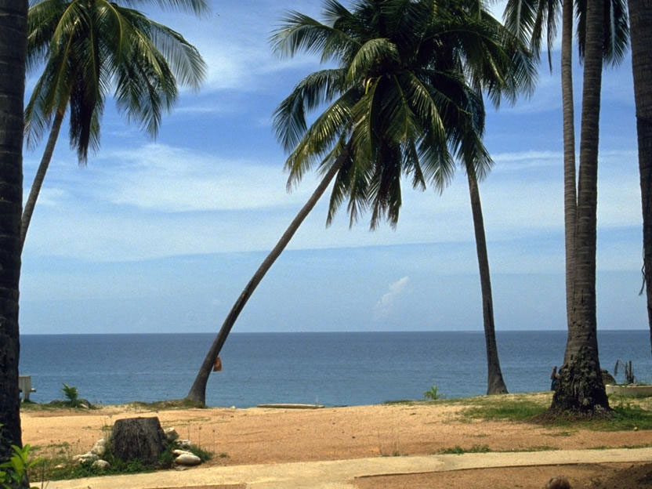

Rasters, also called bitmap, are created on a computer using pixels. Pixels are arranged in grids where their combined colours and tones produce the image. Raster is best used for complex or photographic images.

## Computer graphics

Computer graphics can be described as images that are pictorial. Pictorial means they look like a picture but are not a photograph. Graphics are most commonly thought of as drawings as they are a combination of lines and arcs. Drawing programs like Corel DRAW®, Microsoft® Paint and Adobe® Illustrator® store graphics files as vector images.

Photographs are very complex images composed of many different colours and tones. Photographs are stored and manipulated on a computer as raster images. Photo-editing programs such as Paint Shop Pro®, Adobe® Photoshop® and Macromedia® Fireworks® work by altering the colour or position of individual pixels. Some programs such as Corel DRAW® can process both raster and vector images.

**Digital Image Terminology**

**Pixels** – Short for **Pic**ture **El**ement. A pixel is a single point (dot) in an image.

**Resolution** – The amount of detail in an image. Greater detail is achieved by including more dots (pixels) in the image.

For digital images this is generally measured in dots per inch (dpi). An image with 300 dpi can fit 300 dots in an inch or 90000 per square inch.

For monitors the resolution refers to the number of rows on the screen and the number of dots in each row. A screen set to a resolution of 800x600 is displaying information at 800 pixels horizontally and 600 pixels vertically.

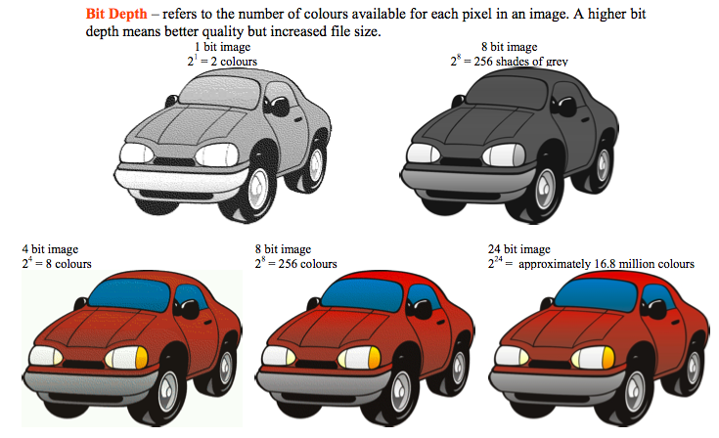

**Resampling** – When you enlarge or reduce a digital image, its pixel dimensions are changed and the image needs to be resampled to bring out detail. When you resample an image which has been made smaller, the number of pixels in an image decreases. Pixel information is actually deleted from the image. When you enlarge an image, the number of pixels is increased based on the colours in the image. New pixel information is added based on matching colour values of existing pixels in the image. In the examples below, both the resized images become fuzzier as pixels are added or removed.

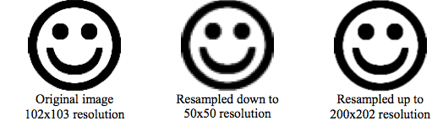

**Megapixels** – One million pixels. The more megapixels a camera has, the higher the image resolution it is capable of printing. Here is how many megapixels are needed for standard print sizes:

**Resolution Total Pixels Max. print size Buy a digicam with**

1600 x 1200 1920000 4x6" 2 megapixels

2048 x 1536 3145728 5x7" 3 megapixels

2560 x 1920 4915200 8x10" 5 megapixels

2816 x 2112 5947392 11x14" 6 megapixels

3264 x 2468 8055552 16 x20" 8 megapixels

**Optical Zoom vs Digital Zoom** – Just because your camera is digital doesn't mean your zoom lens should be! Cameras with digital zoom will not zoom in on your image at all. Instead they will merely enlarge the central portion of the image or trim (crop) the edges from the image. A camera with optical zoom has a lens where the focal length extends and retracts so that the image is actually magnified.

Some more expensive cameras have interchangeable lenses while some of the cheaper ones have no zoom at all.

**Sources**

www.digicamhelp.com

www.webopedia.com

## Clip Art

Clip art is the name given to a collection of graphical images designed to be copied and inserted into other applications, such as a word processor. Clip art was made popular when it was included in many Microsoft® products. Clip art is now widely available on the Internet.

## Icons

Icons are special graphics designed to represent a particular action or meaning. Icons are used because they resemble a function or an object that performs a function. Examples of icons include the image of a house to represent returning home; a picture of binoculars to represent searching; or a magnifying glass that informs a user that it is possible to zoom in or out on an object. Like Clip art, icon libraries are now available on the Internet and compact disc libraries.

